**Introduction**

Welcome to a day where you learn about Sustainability and how to use technology for good. Today’s activities are centered around one of the United Nations Sustainability Development Goals called – [Zero Hunger](https://sdgs.un.org/goals/goal2). Today’s activities will include becoming familiar with the AWS IoT Education Kit and how to use IoT to promote sustainable agriculture.

**Overview of the AWS IoT Education Kit**



**Setup of the device**

Turn on the M5Stack Core 2 and connect the Core 2 to the computer using the provided USB cable.   
Open the following url in a web browser: <https://flow.m5stack.com/> enter the **API KEY on your device** into the Api key field in the web browser. The screenshot below shows an example setup.

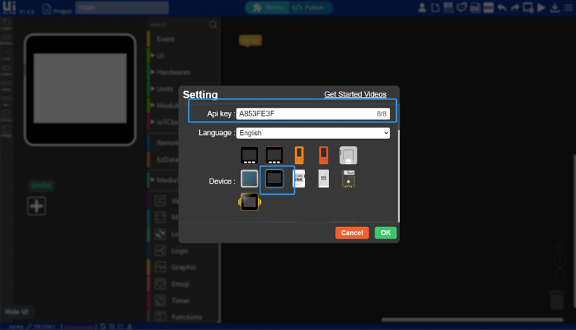

**Let’s get Familiar with UiFLOW**

Let’s learn to play Frere Jacques

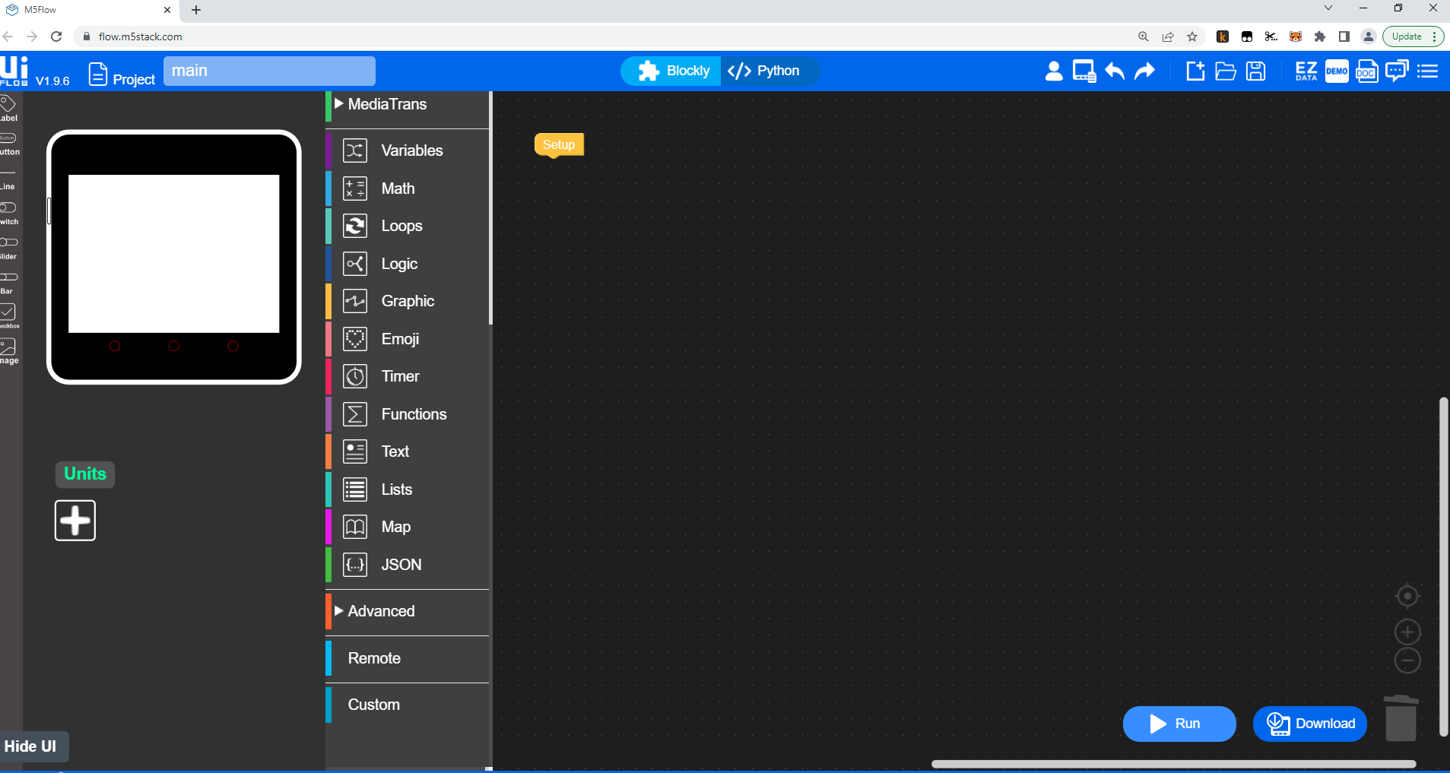

First we start with playing a sound to the speaker of the Core 2. Below are the options that can be used to play the sound from a local WAV file, SD Card, url or a tone for x beats. We will use the ‘play tone’ command in this exercise as underlined in red below.

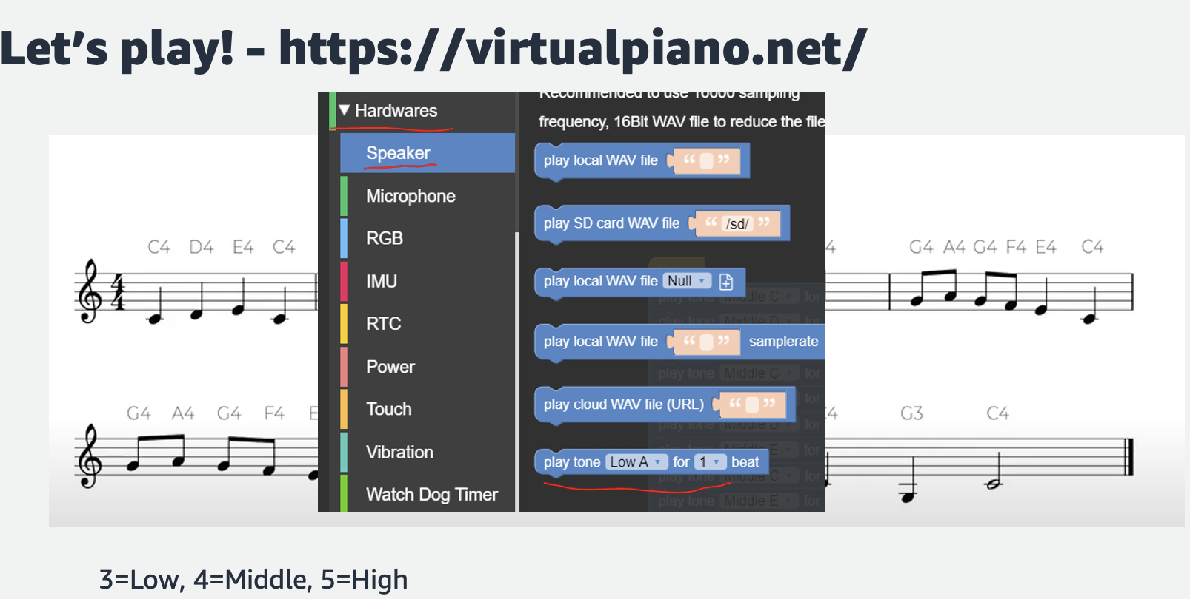

When writing the code in UiFLOW, a C4 music note is played using ‘play tone Middle C for 1 beat’. Similarly, a G3 music note is played using ‘play tone Low G for 1 beat’

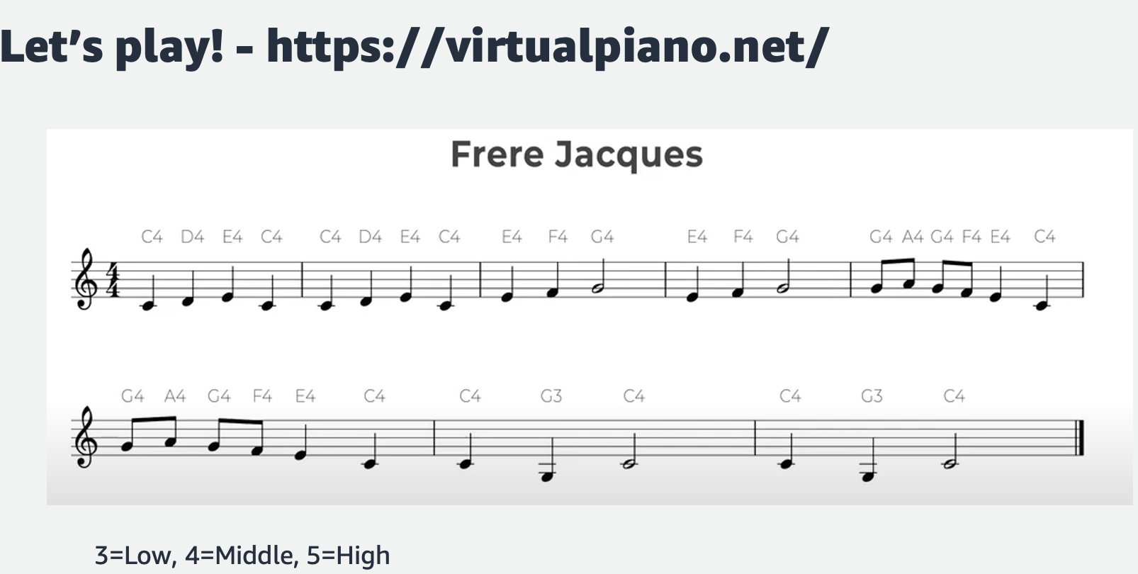

We will use functions/loops to play each music note represented by the relevant tone as described in the paragraph above.

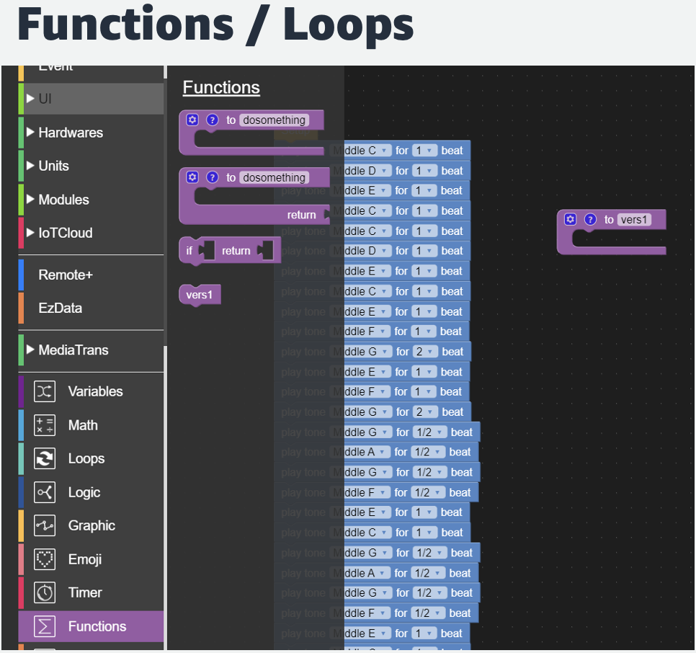

Loops allow the code to be run as many times as the condition is true. In the screenshot below, there are 4 different loops that can be used. For this exercise, we will use the ‘repeat loop’ and repeat the tones as many times as you wish. The example plays the tones 2 times.

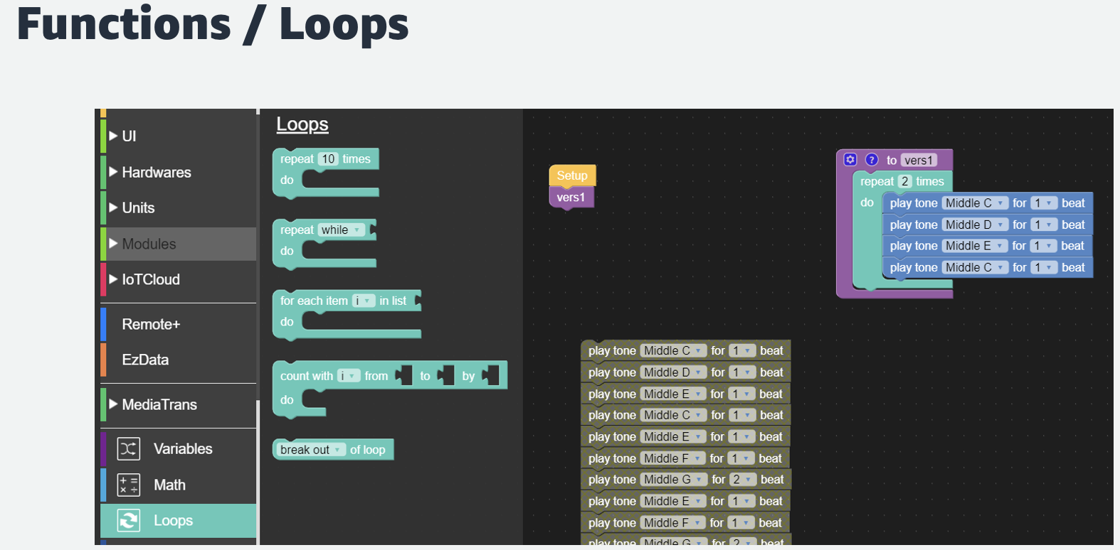

The code below demonstrates how to display each music note to the screen of the Core 2.

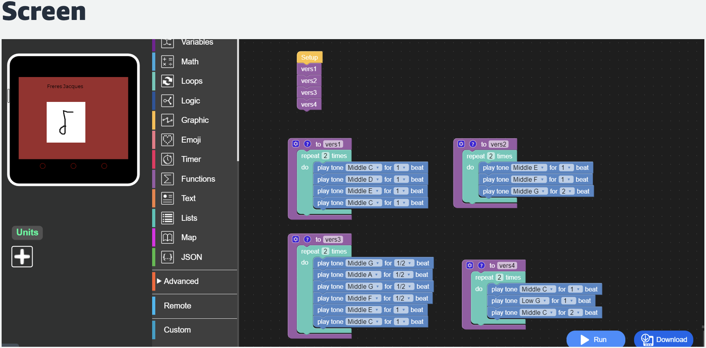

Using buttons to stop/start the music

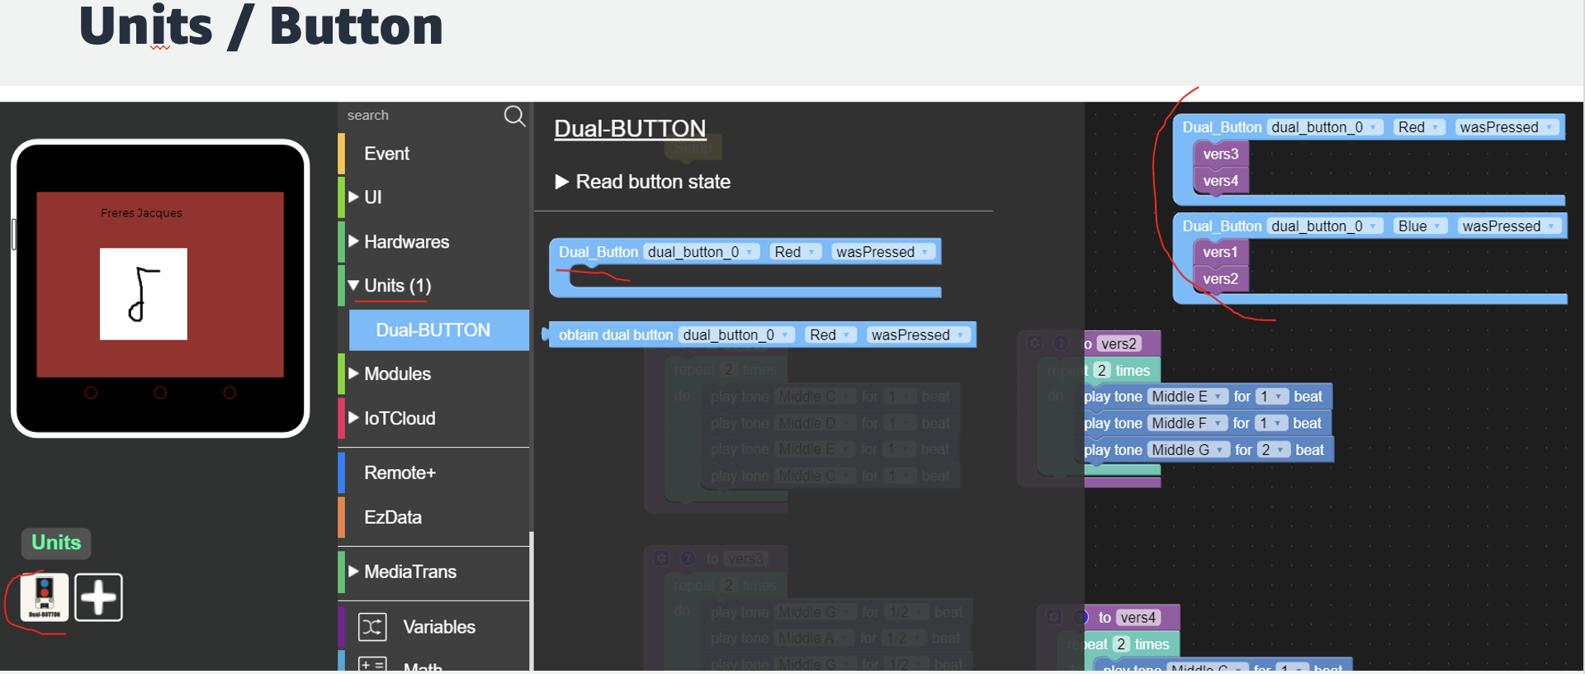

How to build a mobile app:

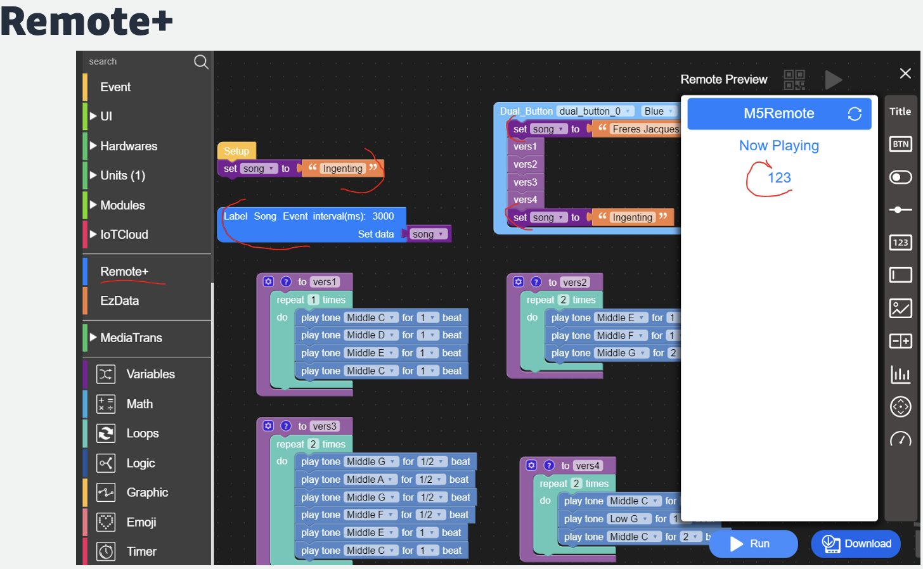

More detailed information on programming with UiFLOW can be found here: [https://m5stack.github.io/UiFLOW_doc/en/en/base/UiFLOW.html](https://m5stack.github.io/UIFlow_doc/en/en/base/UIFlow.html)

Note: Most activities require effort from each team member of the group. Read the activity as a group, look at the required steps and decide on the following roles before starting each activity:

* Activity owner – responsible for coordinating the activity in the group.
* coder - at the keyboard will enter the code told by code guru 2
* code whisperer - tell coder what code blocks to drag in UiFLOW
* researcher 1 – research any numbers/parameters required for the activity. Example – what
* temperature values do you want Core 2 to consider be “HOT, WARM, COLD”
* researcher 2 – support researcher 1

Rotate activity roles in the group as per the [Mob program timer](https://mobtimer.com/)

**Group Activity 1: GET MOVING**

**with Infra-red motion detector sensor**

**Short Intro about the devices required during the challenge**  
In this challenge, we will be using the M5Stack Core 2 and a PIR unit. A passive pyroelectric infrared detector more commonly known as [PIR](https://docs.m5stack.com/en/unit/pir) is a human body infrared unit that detects the infrared radiation emitted and reflected by the human body or object.  
  
**TASK:** Let’s use the PIR sensor to detect movement by displaying messages of ‘Detected’/‘Not Detected’. Select   
  
**Guided steps:**

|  |  |
| --- | --- |
| **Step 1:** Connect the PIR sensor to your Core2 |  |

**Step 2:** Click on this [link](https://flow.m5stack.com/) to open the graphical program editor called UiFLOW and add the following code - follow the instructor/mentor (if needed).   
**Step 3:** Test the code at different stages of the block coding, by using the **RUN** Command  
  
**Step 4:** Download the code to the device using the **Download** button

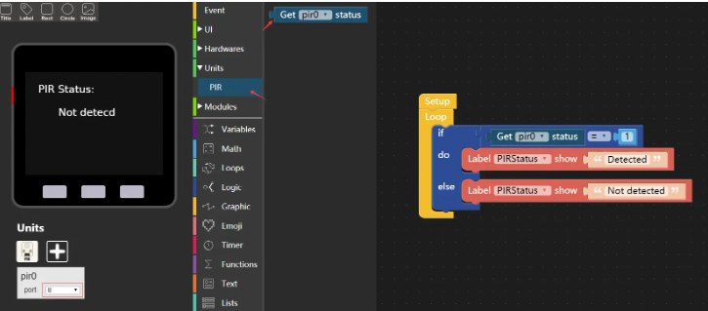  
  
  
**Challenge:** edit the code to turn the screen on when the motion detector detects someone close by. In this way you only use electricity for the screen when needed. Additionally, maybe use sound/tone/beep/song when the motion detector detects motion.

**Group Activity 2: Feel the temperature of the room**

**with the Temperature, Atmospheric Pressure and Humidity Units**

**Short Intro about the devices required during the challenge**  
In this challenge, we will be using the M5Stack Core 2 and the [**ENV III**](https://docs.m5stack.com/en/unit/envIII) unit. The ENV III device can detect temperature, humidity, and atmospheric pressure data. The ENVIII Unit has 2 internal sensors called SHT30 and QMP6988. SHT30 is a high-precision and low-power digital temperature and humidity sensor and the QMP6988 is an absolute air pressure sensor specially designed for mobile applications, with high accuracy and stability, suitable for environmental data collection and detection types of projects

|  |  |
| --- | --- |
| **Step 1:** Remove the PIR sensor from the Core 2 and connect the ENVIII unit (shown below) to the Core 2 |  |

**step 2:** Use UiFLOW to program the Core 2 to read the values from the environmental sensor as illustrated below. Feel free to change colour, font, text size and any other ideas you might have on displaying the values.  
  
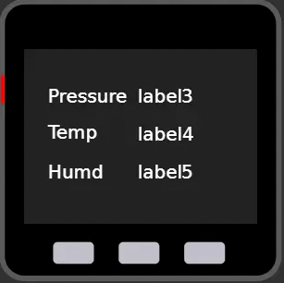  
  
  
**step 3:** once completed walk around the room with the device and see which values change. Discuss amongst each other what each of the values mean and what is being measured.  
  
**Challenge:** Discuss what each value means and as an optional challenge and use the LED function to light up when for example ‘green’ when the temperature is above 20 degrees, ‘blue’ when the temperature is between 15 and 20 and ‘red’ when the temperature is below 15. Use your own values based on your surroundings and try the same for pressure and humidity.

**Group Activity 3: Are you thirsty - measure the soil moisture of each of our plants**

**Short Intro about the devices required during the challenge**  
In this challenge, we will be using the M5Stack Core 2 and the [EARTH](https://docs.m5stack.com/en/unit/earth) Unit. EARTH unit is a Soil Moisture Sensor for measuring the moisture in soil and similar materials.  
The soil moisture sensor usage is pretty straight forward, the two large exposed pads function as probes for the sensor, together acting as a variable resistor. The higher moisture that is in the soil means the better the conductivity between the two so that the sensor will result in a lower resistance, and a higher SIG out.

|  |  |
| --- | --- |
| **Step 1:** Remove the ENVIII Unit from the Core 2 and connect the EARTH unit (shown below) to the Core 2 |  |

**Step 2:** Use UiFLOW to program the Core 2 to read the Analog and Digital values of the soil moisture as illustrated below. Feel free to change colour, font, text size and any other ideas you might have on displaying the values.

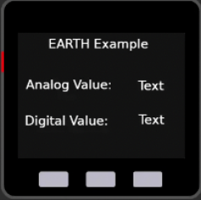

**Challenge:** Discuss what each value means (what value is considered wet or dry) and as an optional challenge, try to program the Core 2 to display a happy/sad face based on the values of the soil moisture or get the Core 2 to vibrate when the soil is dry. Below is a picture of a happy face with a heart.  
  
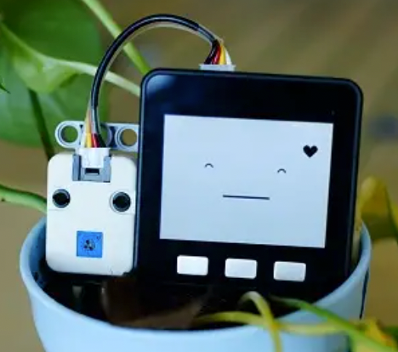

**Group Activity 4: Pump it - Control a pump to supply plants with water**

**Short Intro about the devices required during the challenge**  
In this challenge, we will be using the M5Stack Core 2 and the [Watering](https://docs.m5stack.com/en/unit/watering) Unit. The unit is a capacitive soil moisture detection and adjustment unit which integrates water pump and measuring plates for soil moisture detection and pump water control. It can be used for intelligent plant breeding scenarios and can easily achieve humidity detection and Irrigation control. The measurement electrode plate uses the capacitive design, which can effectively avoid the corrosion problem of the electrode plate in actual use compared with the resistive electrode plate

|  |  |
| --- | --- |
| **Step1:** Remove the Earth unit from the Core 2 and connect the watering unit (shown below) to the Core 2 |  |

**Step 2:** Use the values discussed in Earth unit exercise previously to water the plant when the soil moisture is dry for each of your plants. During testing - water an empty container instead of your plant because once your plant is watered, it will not be watered again until the soil is dry. When ready, water your plants like shown in the picture below. Have fun!   
  
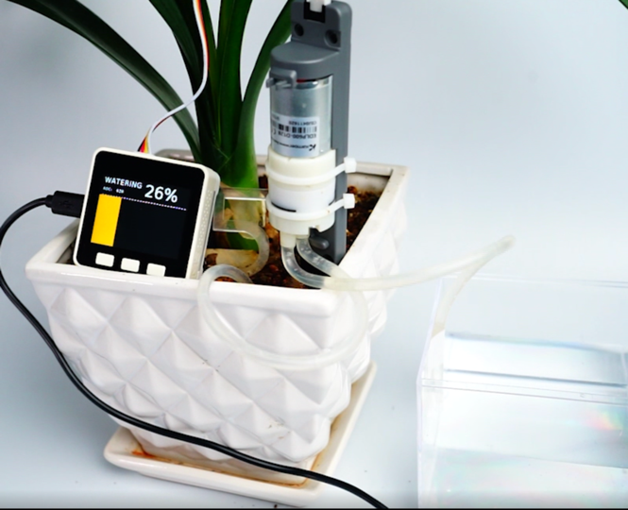

**Challenge Activity: Put it all together**

Automatically water your plant, visualize the state of you plant and turn the display of the Core 2 on when someone is close by. For this you will need 2 Units - PIR and Watering. See the picture below for inspiration – you are welcome to use your own design on the screen to display your plant state  
  
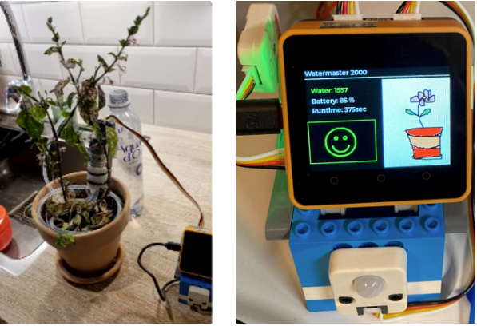

**Stretch Goals**

1. Up in the Cloud - Let you plant talk to the Internet of Things
2. Test other Units: RFID, CO2, Buttons, Microphone
3. Build a small Web/Mobile App for your plant

**Optional Group Activity: Let’s measure CO2 Monitor**

Before we start, there are 2 available CO2 units for use/sharing during the day. Should your group wish to experiment with measuring CO2 levels, reach out to the mentors to see if any of the units are available for use.  
  
**Short Intro about the devices required during the challenge**  
  
**Unit 1:**   
[**CO2**](https://docs.m5stack.com/en/unit/co2) is a photoacoustic Carbon Dioxide (CO2) Unit that will tell you the CO2 PPM (parts-per-million) composition of ambient air. With a built-in Sensirion SCD40 sensor, it has a range of 400~2000 ppm with an accuracy of ±(50 ppm + 5% of reading). What's more, it supports with temperature and humidity measurement too. Perfect for environmental sensing, scientific experiments, air quality and ventilation studies, and more.  
  
**Unit 2:**   
[**TVOC**](https://docs.m5stack.com/en/unit/tvoc) mainly measures various VOC (volatile organic compounds) and H2 in the air. It can be programmed to detect TVOC (total volatile organic compounds) and eCO2 (equivalent carbon dioxide reading) Concentration measurement.  
Typical measurement accuracy is 15% within the measurement range

|  |  |
| --- | --- |
| **Step 1:** Remove the EARTH sensor from the Core 2 and connect one of the 2 available CO2 units (shown below) to the Core 2 |  |

**Step 2:** Use UiFLOW to program the Core 2 to read the CO2, values as illustrated below. Feel free to change colour, font, text size and any other ideas you might have on displaying the values.  
  
**Unit CO2 Unit TVOC/eCO2**  
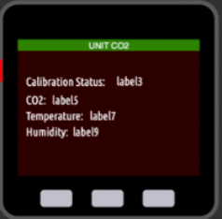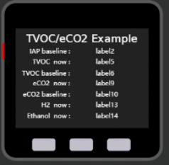

[Tell Us about your day today](https://eventbox.dev/survey/5JBM1VF)

Work hard, have fun, make history